# Lab Manual 8

# Multiplexers

## Objectives:

To learn and understand the working of Multiplexers

## 2x1 MUX:

74LS157 is a high speed Quad 2-Input Multiplexer. Four bits of data from two sources can be selected using the common Select and Enable inputs. The four buffered outputs present the selected data in the true (non-inverted) form.

Function Table

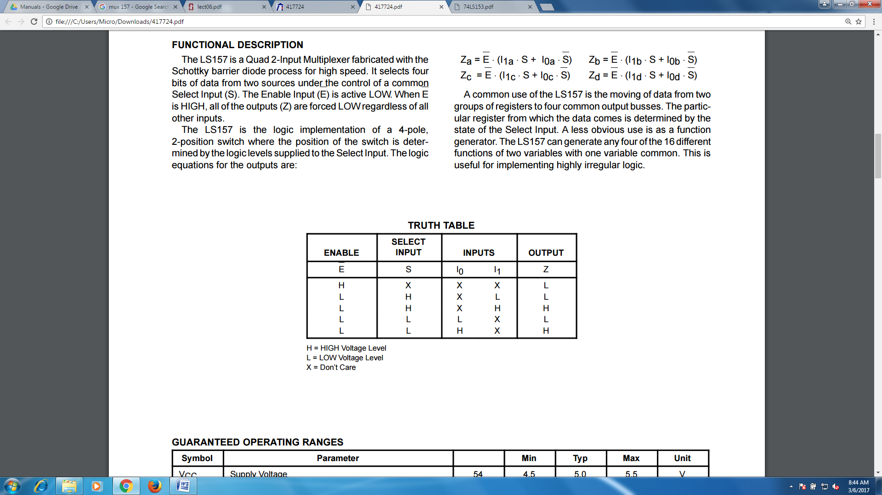

Connection Diagram

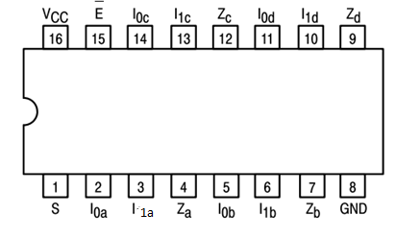

## 4x1 MUX

74LS153 IC is a dual 4x1 MUX with active low enables. Two 4x1 MUXs with common selection pins but independent inputs and independent outputs is known as dual 4x1 MUX. The function table and connection diagram for this IC are shown below:

Function Table

|  |  |  |  |  |  |  |  |
| --- | --- | --- | --- | --- | --- | --- | --- |
| **Strobe (Enable)** | **Selection Inputs** | | **Data Inputs** | | | | **Output** |
| **G** | **B** | **A** | **C0** | **C1** | **C2** | **C3** | **Y** |
| **H** | **X** | **X** | **X** | **X** | **X** | **X** | **L** |
| **L** | **L** | **L** | **L** | **X** | **X** | **X** | **L** |
| **L** | **L** | **L** | **H** | **X** | **X** | **X** | **H** |
| **L** | **L** | **H** | **X** | **L** | **X** | **X** | **L** |
| **L** | **L** | **H** | **X** | **H** | **X** | **X** | **H** |
| **L** | **H** | **L** | **X** | **X** | **L** | **X** | **L** |
| **L** | **H** | **L** | **X** | **X** | **H** | **X** | **H** |
| **L** | **H** | **H** | **X** | **X** | **X** | **L** | **L** |
| **L** | **H** | **H** | **X** | **X** | **X** | **H** | **H** |

H= Logic High, L= Logic Low, X= Don’t Care

Connection Diagram

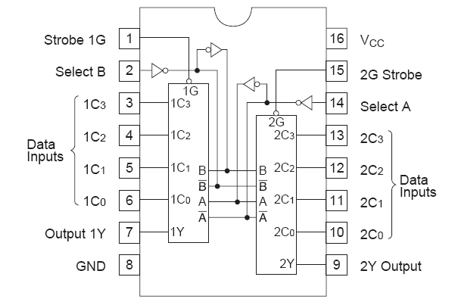

## 8x1 MUX

74LS151 IC is a 8x1 MUX with active low enables. The function table and connection diagram for this IC are shown below:

Function Table and Connection Diagram

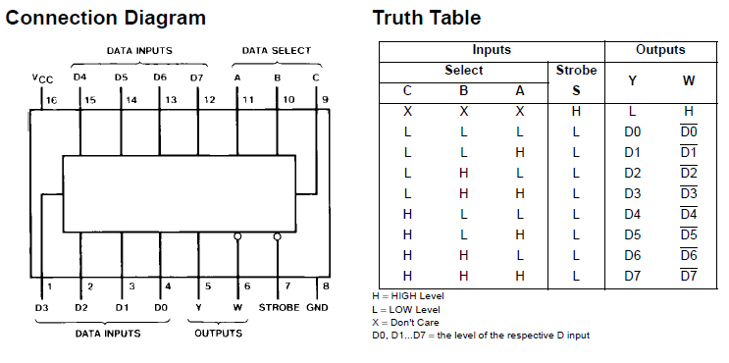

## Problems / Assignments

|  |  |
| --- | --- |
| Problem 1 |  |

Implement four variable function using multiplexer on Logic works. You must use 74_151 components in the Logicworks.

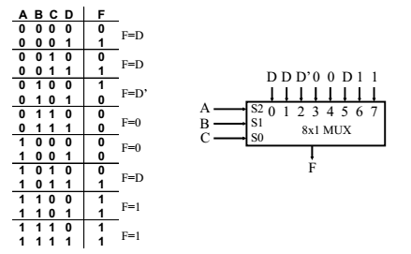

|  |  |
| --- | --- |
| Problem 2 |  |

Implement 4x1 MUX using 2x1 MUX(s) on Logicworks. You must use 74_157 components in the Logicworks

|  |  |
| --- | --- |
| Problem 3 |  |

Make the Truth Table for multiplication of 2- bit binary numbers (Note: You don’t need to submit truth table). Implement the circuit on Logicworks using 8x1 multiplexer(s) and Logic gate (s).

